

Name: Khizar Ali

Roll No: 22P-9269

Subject: Programing Fundamentals LAB

Submitted to: Muhammad Usman

**Problem 1:Union of two sets**

#include <stdio.h>

void findunion(int array1[], int array2[], int size1, int size2)

{

    int i, j, k = 0;

    int array3[100]={0};

    for (i = 0; i < size1; i++)

    {

        for (j = 0; j < size2; j++)

        {

                array3[k] = array1[i];

                k++;

                array3[k] = array2[j];

                k++;

        }

    }

    for (i = 0; i < k; i++)

    {

        for (j = 0; j < k - 1; j++)

        {

            if (array3[j] > array3[j+1])

            {

                int temp = array3[j];

                array3[j] = array3[j+1 ];

                array3[j +1 ] = temp;

            }

        }

    }

 printf("Union of the array is : \n");

    for (i = 0; i < k; i++)

    {

        int flag = 0;

        for (j = 0; j < i; j++)

        {

            if (array3[i] == array3[j])

            {

                flag = 1;

                break;

            }

        }

        if (flag == 0)

        {

            printf("%d ", array3[i]);

        }

    }

}

int main()

{

 int array1[] = {1, 2, 3, 4, 5, 6, 3, 2};

int array2[] = {1, 3, 5, 7};

int size1 = 8;

int size2 = 4;

    findunion(array1, array2, size1, size2);

    return 0;

**}**

**Output:**

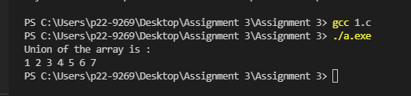

**Problem 2: Matrix Multiplication.**

#include<stdio.h>

int main()

{

    int a[10][10], b[10][10],  r1, c1, r2, c2, i, j, k;

  int result[10][10]={0};

    printf("Enter rows  for first matrix: \n");

    scanf("%d",&r1);

    printf("Enter Column  for first matrix: \n");

    scanf("%d",&c1);

    printf("Enter rows  for second matrix: \n");

    scanf("%d",&r2);

    printf("Enter Column  for second matrix: \n");

    scanf("%d",&c2);

    // If column of first matrix in not equal to row of second matrix,

    if  (c1!=r2)

       {

        printf("Matrix cannot be multiplied");

      }

   // Storing elements of first matrix.

   else

   {

    printf("\nEnter elements of matrix 1:\n");

    for(i=0; i<r1;  i++)

        for(j=0; j<c1;j++)

        {

            scanf("%d", &a[i][j]);

        }

    // Storing elements of second matrix.

    printf("\nEnter elements of matrix 2:\n");

    for(i=0; i<r2;  i++)

    {

        for(j=0; j<c2;j++)

        {

            scanf("%d",&b[i][j]);

        }

    }

    // Displaying  matrices a and b

    printf("Matrix 1 is \n ") ;

    for(i=0; i<r1; i++)

       { for(j=0; j<c1; j++)

        {

            printf("%d \t",a[i][j]);

        }

        printf("\n");

       }

        printf("Matrix 2 is \n ");

    for(i=0; i<r1;i++)

       { for(j=0; j<c1; j++)

        {

            printf("%d \t",b[i][j]);

        }

        printf("\n");

       }

    // Multiplying matrices a and b &  storing result in result matrix

    for(i=0; i<r1; i++)

      {  for(j=0; j<c2; j++)

        {

            for(k=0; k<c1; ++k)

            {

                result[i][j]=result[i][j]+a[i][k]*b[k][j];

            }

        }

      }

    // Displaying the result

    printf("\nOutput Matrix:\n");

    for(i=0; i<r1;  i++)

       { for(j=0; j<c2; ++j)

        {

            printf("%d \t ", result[i][j]);

        }

        printf("\n");

       }

   }

    return 0;

}

**OUTPUT**

If number of rows and columns are not equal:

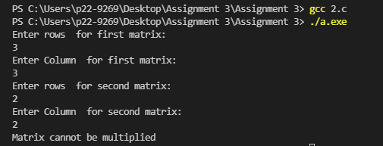

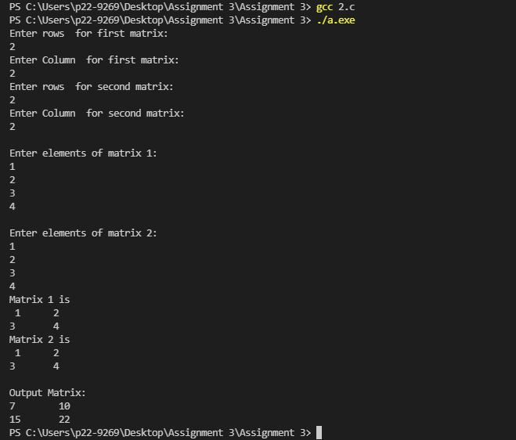When Number of rows and column are equal:

**Problem 3:** **GPA Calculator**

#include<stdio.h>

#include<string.h>

int main()

{

    float points=0,total=0,GPA,  credithour=0,totalhour=0;

    char grade[10];

    int subjects;

    printf("Enter Number of sujects ");

    scanf("%d",&subjects) ;

    for(int i= 1; i<=subjects;i++)

    {

        printf("Enter your grade in subject (%d) \n",i );

        scanf("%s",grade);

        printf("Enter your Credit hour of  subject (%d) \n",i);

        scanf("%d",&credithour);

        totalhour=totalhour+credithour;

        if ( strcmp(grade,"A" ) == 0 )

        {

            points=4.0;

        }

        else if (strcmp (grade , "A-")==0)

        {

            points=3.67;

        }

          else if (strcmp (grade , "B+")==0)

        {

            points=3.33;

        }

          else if (strcmp (grade , "B")==0)

        {

            points=3.0;

        }

          else if(strcmp (grade , "B-")==0)

        {

            points=2.67;

        }

          else if (strcmp (grade , "C+")==0)

        {

            points=2.33;

        }

          else if (strcmp (grade , "C")==0)

        {

            points=2.0;

        }

          else if (strcmp (grade , "C-")==0)

        {

            points=1.67;

        }

          else if (strcmp (grade , "D+")==0)

        {

            points=1.33;

        }

          else if (strcmp (grade , "D+")==0)

        {

            points=1.00;

        }

          else if (strcmp (grade , "F")==0)

        {

            points=0;

        }

     total=total+points*credithour;

    }

GPA=total/totalhour;

printf("Your GPA is %.2f ",GPA);

return 0;

}

**Output:**

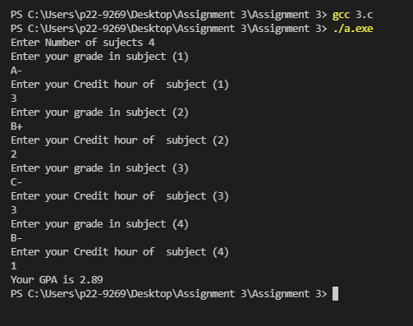

**Problem 4: Restaurant Menu**

#include<stdio.h>

#include<string.h>

int menu1()

{ char size;

int input=0,total=0,price=0;

 printf("......................espresso & mocha chiller:.........................\n");

            printf("1. Very vanilla Chiller:\n price: small=361 regular= 409 \n");

            printf("2. Coco Locd: \n price: small=361 regular= 409 \n");

            printf("3. Cookies n cream:\n price: small=361 regular= 409 \n");

            printf("4. HAZELNUT MOCHA CHILLER:\n Price:  small= 396  regular= 461\n");

            printf("5. CHOCOLATE MACADAMIA CHILLER:\n Price:  small= 396  regular= 461\n");

            printf("6. ITALIAN DOLCE CHILLER:\n Price:  small= 396 regular= 461\n");

            printf("7. CARAMEL NUT CHILLER:\n Price:  small= 396  regular= 461\n");

            printf("8. TIRAMISU CHILLER:\n Price:  small= 399 regular= 509\n");

            printf("9. TOFFEE NUT CHILLER:\n Price:  small= 399 regular= 509\n");

            printf("Enter R for regular and S for  small \n");

            scanf("\n %c",&size);

            printf("Choose  the Number \n ");

            scanf("\n%d",&input);

            if(input==1 && size=='R' || size=='r')

            {

              price=409;

              total=total+price;

            }

            else if((input==1 && size=='S' || size=='s'))

            {

              price=361;

              total=total+price;

            }

             else if((input==2 && size=='R' || size=='r'))

            {

              price=409;

              total=total+price;

            }

             else if((input==2 && size=='S' || size=='s'))

            {

              price=361;

              total=total+price;

            }

             else if((input==3 && size=='R' || size=='r'))

            {

              price=409;

              total=total+price;

            }

             else if((input==3 && size=='S' || size=='s'))

            {

              price=361;

              total=total+price;

            }

              else if((input==4 && size=='S' || size=='s'))

            {

              price=396;

              total=total+price;

            }

              else if((input==4 && size=='R' || size=='r'))

            {

              price=461;

              total=total+price;

            }

            else if((input== 5 && size=='S' || size=='s'))

            {

              price=396;

              total=total+price;

            }

              else if((input==5  && size=='R' || size=='r'))

            {

              price=461;

              total=total+price;

            }

            else if((input==6 && size=='S' || size=='s'))

            {

              price=396;

              total=total+price;

            }

              else if((input==6 && size=='R' || size=='r'))

            {

              price=461;

              total=total+price;

            }

            else if((input==7 && size=='S' || size=='s'))

            {

              price=396;

              total=total+price;

            }

              else if((input==7 && size=='R' || size=='r'))

            {

              price=461;

              total=total+price;

            }

            else if((input==8 && size=='S' || size=='s'))

            {

              price=399;

              total=total+price;

            }

              else if((input==8 && size=='R' || size=='r'))

            {

              price=509;

              total=total+price;

            }

             else if((input== 9&& size=='S' || size=='s'))

            {

              price=399;

              total=total+price;

            }

              else if((input==9  && size=='R' || size=='r'))

            {

              price=509;

              total=total+price;

            }

            return total;

}

int menu2()

{  char size;

int input=0,total=0,price=0;

            printf("..............Over Ice............ \n");

            printf("1. SIGNATURE ICED COFFEE \n price: small=300 regular= 374 \n");

            printf("2. ICED MOCHA : \n price: small=300 regular= 361 \n");

            printf("3. ICED CARAMEL LATTE:\n price: small=378 regular= 430 \n");

            printf("4. ICED AMERICAND: \n Price:  small= 252  regular= 274\n");

            printf("5. BLUEBERRY LEMONADE: \n Price:  small= 250  regular= 291 \n");

            printf("6. LYCHEE LEMONADE: \n Price:  small= 250  regular= 291\n");

            printf("7. GREEN APPLE LEMONADE:\n Price:  small= 250  regular= 291\n");

            printf("8. PEACH LEMONADE:\n Price: small= 250  regular= 291\n");

            printf("9. APPLE SODA:\n Price:  small= 335 regular= 348\n");

            printf("10. LIME SODA:\n Price:  small= 335 regular= 361\n");

            printf("11. ICED TEAS (Peach/Lemon Lycheel:\n Price:  small= 239  regular= 291 \n");

            printf("Enter R for regular and S for  small \n");

            scanf("\n%c",&size);

            printf("Choose  the Number \n ");

            scanf("\n%d",&input);

            if(input==1 && size=='R' || size=='r')

            {

              price=374;

              total=total+price;

            }

            else if((input==1 && size=='S' || size=='s'))

            {

              price=300;

              total=total+price;

            }

             else if((input==2 && size=='R' || size=='r'))

            {

              price=361;

              total=total+price;

            }

             else if((input==2 && size=='S' || size=='s'))

            {

              price=300;

              total=total+price;

            }

             else if((input==3 && size=='R' || size=='r'))

            {

              price=430;

              total=total+price;

            }

             else if((input==3 && size=='S' || size=='s'))

            {

              price=378;

              total=total+price;

            }

              else if((input==4 && size=='S' || size=='s'))

            {

              price=252;

              total=total+price;

            }

              else if((input==4 && size=='R' || size=='r'))

            {

              price=274;

              total=total+price;

            }

            else if((input== 5 && size=='S' || size=='s'))

            {

              price=250;

              total=total+price;

            }

              else if((input==5  && size=='R' || size=='r'))

            {

              price=291;

              total=total+price;

            }

            else if((input==6 && size=='S' || size=='s'))

            {

              price=250;

              total=total+price;

            }

              else if((input==6 && size=='R' || size=='r'))

            {

              price=291;

              total=total+price;

            }

            else if((input==7 && size=='S' || size=='s'))

            {

              price=250;

              total=total+price;

            }

              else if((input==7 && size=='R' || size=='r'))

            {

              price=291;

              total=total+price;

            }

            else if((input==8 && size=='S' || size=='s'))

            {

              price=250;

              total=total+price;

            }

              else if((input==8 && size=='R' || size=='r'))

            {

              price=291;

              total=total+price;

            }

             else if((input== 9&& size=='S' || size=='s'))

            {

              price=335;

              total=total+price;

            }

              else if((input==9  && size=='R' || size=='r'))

            {

              price=348;

              total=total+price;

            }

             else if((input==  10 && size=='S' || size=='s'))

            {

              price=335;

              total=total+price;

            }

              else if((input==10 && size=='R' || size=='r'))

            {

              price=341;

              total=total+price;

            }

             else if((input== 11 && size=='S' || size=='s'))

            {

              price=239;

              total=total+price;

            }

              else if((input== 11  && size=='R' || size=='r'))

            {

              price=391;

              total=total+price;

            }

             return total;

}

int menu3()

{  char size;

int input=0,total=0,price=0;

 printf("..............Chochlate chiller ............ \n");

            printf("1. ORIGINAL ICED CHOCOLATE: \n price: small=348 regular= 365 \n");

            printf("2. WHITE ICED CHOCOLATE : \n price: small=348 regular= 365 \n");

            printf("3. CHOCOLATE DELIGHT:\n price: small=348  regular= 400 \n");

            printf("Enter R for regular and S for  small \n");

            scanf("\n%c",&size);

            printf("Choose  the Number \n ");

            scanf("\n%d",&input);

            if(input==1 && size=='R' || size=='r')

            {

              price=365;

              total=total+price;

            }

            else if((input==1 && size=='S' || size=='s'))

            {

              price=348;

              total=total+price;

            }

             else if((input==2 && size=='R' || size=='r'))

            {

              price=365;

              total=total+price;

            }

             else if((input==2 && size=='S' || size=='s'))

            {

              price=348;

              total=total+price;

            }

             else if((input==3 && size=='R' || size=='r'))

            {

              price=400;

              total=total+price;

            }

             else if((input==3 && size=='S' || size=='s'))

            {

              price=348;

              total=total+price;

            }

             return total;

}

int menu4()

{

 char size;

int input=0,total=0,price=0;

 printf(".............. FUSION ............ \n");

            printf("1.ICED LIME : \n price: small=335 regular= 365 \n");

            printf("2.APPLE CHILLER: \n price: small=335 regular= 365 \n");

            printf("3.CHAI CHILLER:\n price: small=348  regular= 400 \n");

            printf("4.GREEN TEA CHILLER:\n price: small=348  regular= 400 \n");

           printf("Enter R for regular and S for  small \n");

            scanf( "\n%c",&size);

            printf("Choose  the Number \n ");

            scanf("\n%d",&input);

            if(input==1 && size=='R' || size=='r')

            {

              price=365;

              total=total+price;

            }

            else if((input==1 && size=='S' || size=='s'))

            {

              price=335;

              total=total+price;

            }

             else if((input==2 && size=='R' || size=='r'))

            {

              price=365;

              total=total+price;

            }

             else if((input==2 && size=='S' || size=='s'))

            {

              price=335;

              total=total+price;

            }

             else if((input==3 && size=='R' || size=='r'))

            {

              price=400;

              total=total+price;

            }

             else if((input==3 && size=='S' || size=='s'))

            {

              price=348;

              total=total+price;

            }

               else if((input== 4 && size=='R' || size=='r'))

            {

              price=400;

              total=total+price;

            }

             else if((input== 4 && size=='S' || size=='s'))

            {

              price=348;

              total=total+price;

            }

             return total;

}

int main()

{

    char Menu[10];

    int a=0,b=0,c=0,d=0, total=0,SR=500;

    float tax=0,Stotal=0;

    printf(">>>>>>>>>>>>>>>>>>>> Menu >>>>>>>>>>>>>>>>>>>>>>>>>>>>>>>>>>>\n ");

   for ( int i= 1;;i++)

    {

       printf(" 1. Espresso & MOCHA CHILLER:\n");

       printf(" 2. Over ice: \n");

       printf(" 3. Choclate Chiller:\n");

       printf(" 4. Fusion  \n");

       printf("Enter N to exit \n");

       printf("Select the menu you want  \n",i );

        scanf("\n%s",Menu);

        if ( strcmp(Menu, "1" )==0)

           a=menu1();

       else  if ( strcmp(Menu, "2" )==0)

            {

            b=menu2();

            }

       else if ( strcmp(Menu, "3" )==0)

            {

           c= menu3();

            }

        else if ( strcmp(Menu, "4" )==0)

           {

           d=menu4();

           }

         else if ( strcmp(Menu, "No" )==0 || strcmp(Menu,"N")==0 || strcmp(Menu,"n")==0)

        {

          break;

        }

          total=a+b+c+d;

     }

         printf("Your bill without S.R and tax is %d \n ",total);

         SR=500;

         printf("Service charge = %d \n",SR);

         tax=(20*total)/100;

         printf("Your TAX is = %.2f\n",tax);

         Stotal=SR+tax+total;

     printf("Your Total Bill is %.2f",Stotal);

        return 0;

}

**Output:**

